Pre-application Advice Report

Site Address:  Owlthorpe E updated layout | Pre-app enquiry ref:  19/02510/PREAPP
- We understand your proposal to be....
Revised layout Option 2 – 007_02_ Rev G
- Advice
In this section we will say what we think about your proposal. This will include our view about the likelihood of permission being granted and what might be done to improve the prospects, where relevant.

The revised layout has addressed some of the comments previously made on 11.6 but we would recommend that the following points are given further consideration
- Woodland edge
The layout appears too loose as currently proposed, and has a lot of ‘left over’ green space. We acknowledge the setback required-although the plan needs to show more clearly where the 15 M line is located. A response could be to have a drive/ road along the woodland edge outside the 15m line as achieved in other locations- for example Norfolk park housing company sites, as was illustrated in the planning brief as an option. Introducing this along with adjusting the main access road will allow for a fuller cluster of development.
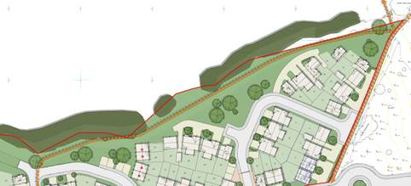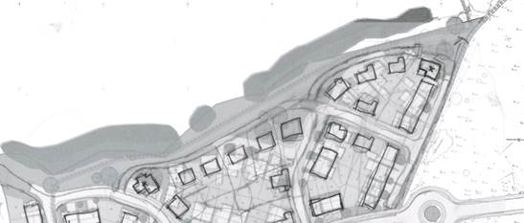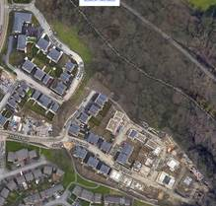
Norfolk Park development, Sheffield
- Street hierarchy and central node:
Some tightening of built frontages is required along the main route as previously advised, for example the new road alignment could be changed to incorporate the bottom section of drive (that creates a strip of soft landscaping sandwiched by two roads!). This will make the open space, and the central node better defined and purposeful.
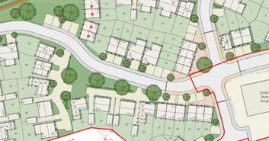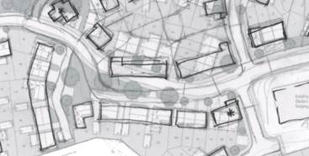

- Definition of spaces and nodes:

As mentioned previously there are areas within the layout that are weak, accepting the central spine can be adjusted as above, the other three locations are as follows:
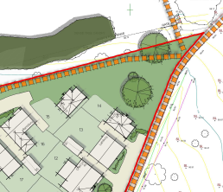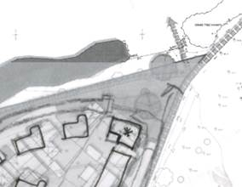
Northern corner- do feel this needs to have a better response with development pulled as much forward as it can be and specific house type/ large house indicated.

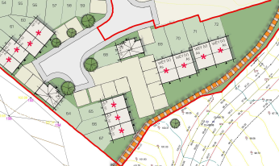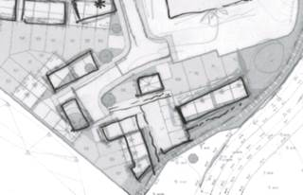

Land south of the medical centre- accepting this will be built upon instead of open space now, the layout needs to respond better to the public footpath- with houses turned, boundary treatments provided to achieve this.
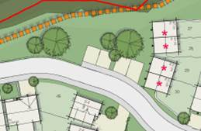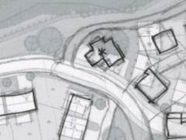

west edge of the woodland- again as above this needs a better response.

See the sketch in full below to avoid confusion, obviously it is an illustration only.

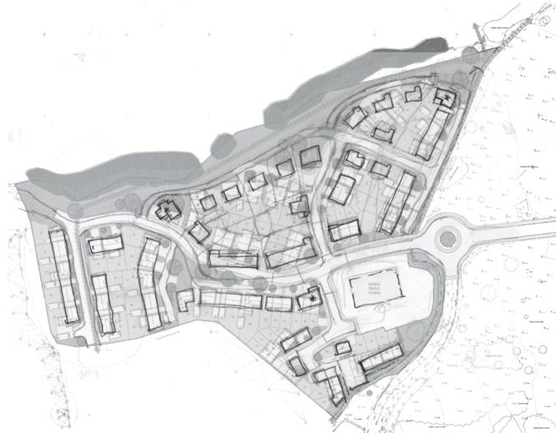

Amenity issues
The layout appears too crammed in the southern corner where the affordable units are located, particularly as the levels are very challenging in the this location and there are likely to be retaining structures and significant slopes which do not appear on the plans at this stage. Plot 60 has an excessively small irregular shaped garden and this property would overlook plots 55/56. Some of the plots have little defensible space to the front and provision does not appear to have been made for footpath connections to the front door and bin storage at the front where there is no separate path to the rear garden, (3 bins in Sheffield).
Other plots with overlooking issues that need addressing are plots 40/49, 8/7.
Highways and Ecology responses are to follow when officers have had time to review the amended scheme.
Open Space Provision
It is noted that the latest layout removes the play area from the site following discussion with the Council that this and MUGA would be best located together on land to the south of site C. I believe your client has accepted the desire to provide the whole of the play provision together at an early stage of the development in order to achieve the best community outcome, to avoid delays if it were reliant on contributions from later phases of housing and to help ease the passage of the scheme with the community. I understand it is intended to include the park/play provision within the red line boundary for site E and it is accepted that conditions will be attached (which will be the subject of future discussions) regarding the delivery and content of the open space scheme. We support this approach but consider that it is important residents have some information on what is proposed. Ideally we would like to see a masterplan for the open space area so that we could perhaps approve a set of principles for the detailed design of the open space area as part of the site E application. I understand that property are exploring ways in which a piece of work can be brought forward which will help to define these principles which would also establish principles for overlooking, views of the site, connections etc which would guide the future development on site C. Ideally this work should input to the submission of a draft layout for the open space area which is submitted in support of the application for site E. This would help to show residents what to expect particularly those of the nearest housing (Moorthrope Dell). If the application for site E just shows a red line around the open space area with no detail this is likely to fuel speculation by residents of the worst case option.
Affordable Housing
Whilst I have not consulted housing colleagues again given the limited pre-app fee agreed for commenting on this latest layout I have noticed that the affordable units identified on the plan do not match those in the table and the number of smaller units and the overall number of units has reduced. I would draw you attention to the previous advice regarding the affordable housing units.

Case officer: Howard Baxter | Date 11.07.19

NB The views given will be current at the time of giving advice, but changes in planning circumstances can occur and will need to be taken into account when any subsequent application is submitted. These views are also given without prejudice to any eventual Committee decision on an application.

